



Program Manager: Lula Jean Burton

Somerset-Pulaski County Chamber of Commerce

445 South Highway 27, Suite 101

Somerset, KY 42501

(606)679-7323 or (606) 875-2343

Email: lulajeanburton001@gmail.com

https://www.facebook.com/yeasomersetpulaski/



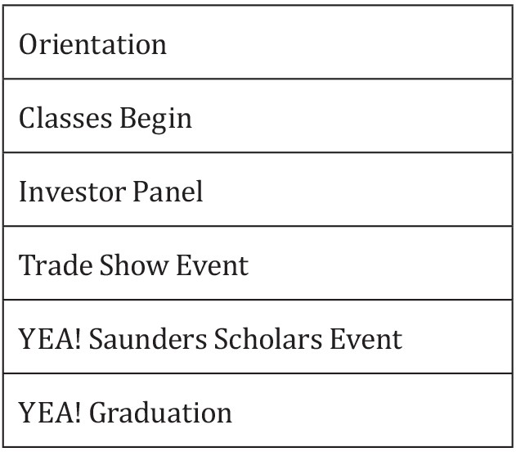



|  |
| --- |
| **November 2016** |
| **November 2016** |
| **March 2017** |
| **May 2017** |
| **May 2017** |
| **May 2017** |







**YEA! Academic Year $XXXX**

Academic year begins in November and ends in May

Classes meet every **Tuesday**

from **4:00 p.m.** to **7:00 p.m**.

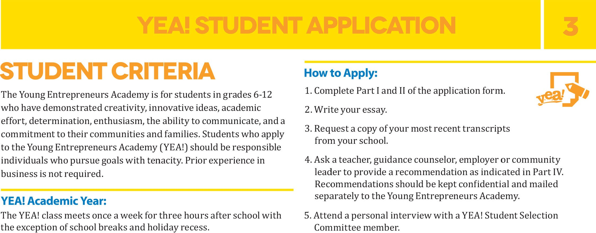

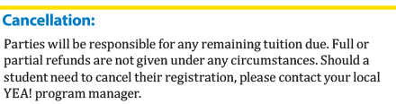

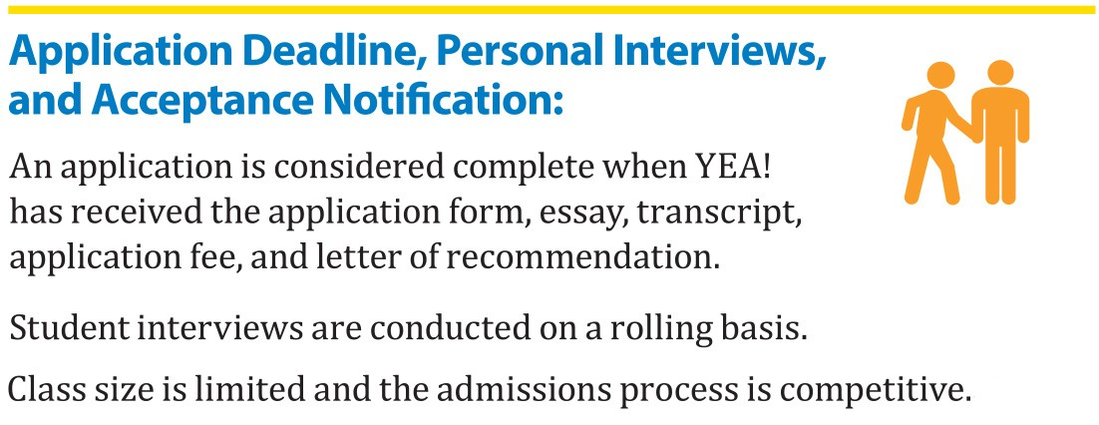

Deadline for applications for the 2016–2017 year is

**September 30, 2016.**



**YEA! Academic Year**

**$395**

6. Enclose your **$10** application fee with your completed application and mail to:

**Young Entrepreneurs Academy (ATTN: Lula Jean Burton)**

**Somerset-Pulaski County Chamber of Commerce**

**445 South Highway 27, Suite 101**

**Somerset , KY 42501**

